**ADVANCED ATTENDANCE TRACKING THROUGH FACIAL RECOGNITION TECHNOLOGY**

|  |  |
| --- | --- |
| Pranav Sanjay Manapure  Vellore Institute of Technology, Chennai  Tamil Nadu, India  [pranav.sanjay2023@vitstudent.ac.in](mailto:pranav.sanjay2023@vitstudent.ac.in) | Dr. N. Prem Sankar  Vellore Institute of Technology, Chennai  Tamil Nadu, India  [premsankar.n@vit.ac.in](mailto:premsankar.n@vit.ac.in) |

***Abstract-* Facial recognition technology is increasingly being integrated into smart attendance monitoring systems, enabling automatic identification and verification of individuals for attendance**

**purposes. This modern approach offers several advantages over traditional methods, such as handwritten sign-in sheets or RFID cards. With this technology, students or employees simply need to walk in front of a camera to have their attendance recorded, eliminating the need to carry identification cards or electronic devices. Smart attendance systems can also be implemented using CCTV cameras, which require careful placement and optimization to capture clear and consistent images for accurate facial recognition. This is particularly beneficial in large organizations, as it can save time, reduce stress, enhance security, lower costs, and boost productivity. However, it is crucial to address privacy concerns and ensure that the technology is used ethically and responsibly. Facial recognition can identify individuals even in challenging conditions, such as low light or crowded areas. While these systems offer numerous benefits over traditional methods, it is important to implement them thoughtfully and accurately.**

***Keywords-*** Convolutional Neural Networks (CNN), Support Vector Machine (SVM), Face recognition (FR), Machine Learning (ML), Deep Learning (DL), Local Binary Pattern Histogram (LBPH), Principal Component Analysis (PCA) and Linear Discriminant Analysis (LDA).

# **I. Introduction**

Facial recognition is one of the most advanced fields in artificial intelligence and computer vision, which has revolutionized the way we authenticate and identify individuals. This technology involves the accurate identification of individuals based on unique facial features, offering a promising method for attendance monitoring systems. The deployment of facial recognition in attendance monitoring systems has gained special attention due to its potential to address various important challenges present in traditional attendance systems.

Face recognition is a technology that uses computer algorithms and machine learning to identify and verify individuals by analyzing their facial features in images and videos. It mainly detects faces in the system, extracts unique characteristics, and compares them to known faces for tasks like authentication, security, access control, etc. It is also utilized in diverse domains, including law enforcement, customer service, and personalized marketing. It is also showcasing great potential to transform and develop various aspects of modern life and business operations.



Figure(1): Person is trying to detecting face of themselves for marking attendance in class.

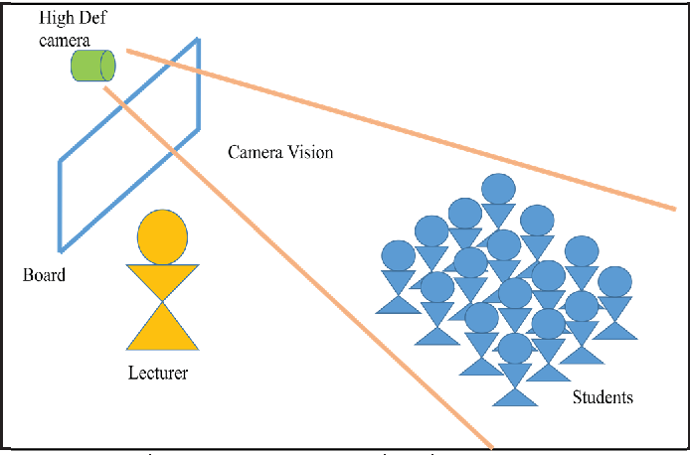A smart attendance monitoring system based on facial recognition is a better solution for atomizing and optimizing the process of tracking and recording attendance. This can utilize facial algorithms to identify individuals in a given area. This system eliminates the need for traditional manual methods and increases accurate, efficient, and secure attendance management. It can be used in educational institutions, businesses, and other organizations to improve attendance monitoring and overall system operation efficiency. This system improves security and reduces the risk of attendance fraud by ensuring that individuals are physically present during the checking process, making it a reliable and better solution for attendance management.

Figure(2): Single Camera is detecting face of all students present in class for marking their attendance

This review delves into the current state of research on implementing facial recognition for attendance monitoring systems, particularly focusing on the utilization of Facenet and K-Nearest Neighbors (KNN) algorithms. Recent advancements in deep learning techniques like Facenet have opened doors for highly accurate facial recognition. This, coupled with the efficiency and contactless operation of KNN-based approaches, presents a compelling solution for attendance management.

# **II. Literature Work**

The literature review is categorized into three primary domains to explore the advancements and methodologies employed in facial recognition for attendance systems: **Image Processing**, **Machine Learning**, and **Deep Learning**.

**A. Image Processing**

Image processing forms the foundation for identifying and verifying facial regions within images, enabling precise facial recognition in attendance systems.

* **Student Attendance with Face Recognition (LBPH or CNN): Systematic Literature Review**  
  Budimana et al. [1] conducted a comprehensive analysis of 30 research articles to evaluate the efficacy of the Local Binary Pattern Histogram (LBPH) and Convolutional Neural Network (CNN) algorithms in student attendance systems. Using the PRISMA methodology, the study highlighted factors affecting accuracy, such as camera quality and facial orientations. The results indicated that CNN generally outperforms LBPH in terms of recognition accuracy in surveillance scenarios.
* **Face Recognition in Attendance Systems: A Systematic Review**  
  Anshari et al. [2] employed the Kitchenham method to systematically review facial recognition systems across organizational contexts. This study explored security measures and implementation success factors, emphasizing the importance of balancing security with usability.
* **Face Recognition-Based Attendance Management System**  
  Smitha, Hegde, and Afshin [5] proposed an automated attendance system utilizing a Haar Cascade Classifier for face detection and LBPH for recognition. Their system efficiently records attendance, generates reports, and sends absentee notifications via email.
* **Facial Recognition Attendance Monitoring Utilizing Deep Learning Techniques**  
  Manjula et al. [9] combined Eigenfaces, Fisherfaces, and LBPH approaches with Euclidean distance metrics for enhanced facial feature extraction. This method delivers reliable real-time attendance tracking.
* **Case Study at MEDIU Using Viola-Jones for Face Detection**  
  Huda and Hilles [4] developed an automated attendance system for Al-Madinah International University. Using the Viola-Jones algorithm and a tailored dataset (MEDUE-S-V-DB), the study achieved improved tracking accuracy in diverse facial attributes using video data.

**B. Machine Learning**

Machine learning algorithms enhance the efficiency of attendance systems by employing classifiers and decision trees for accurate recognition.

* **Feature-Based Algorithms for Face Recognition in Attendance Systems**  
  Gowda et al. [6] developed a model using decision tree and support vector machine classifiers to optimize facial feature classification. Deep metric learning was employed to refine the recognition process, enhancing both efficiency and accuracy.
* **A Smart Attendance System Based on Facial Recognition Using Deep Transfer Learning**  
  Alhanaeea et al. [7] utilized transfer learning with pretrained networks such as SqueezeNet and GoogleNet. Their study demonstrated the benefits of data augmentation and fine-tuning, resulting in a flexible model adaptable to new datasets.

**C. Deep Learning**

Deep learning has transformed facial recognition by leveraging advanced neural network architectures, such as CNN and ResNet, to achieve high accuracy in real-world scenarios.

* **Single Sample Face Recognition Using CNN**  
  Filippidou and Papakostas [8] employed CNN models (MobileNetV2, ResNet50V2, DenseNet121, and InceptionV3) for single-sample face recognition. Their system achieved up to 100% accuracy in optimal conditions, supporting both in-person and online attendance.
* **Face Recognition for Real-Time Classroom Attendance**  
  Singh et al. [15] developed a real-time system integrating webcam feeds with Haar Cascade Classifier for face detection and LBPH for recognition. The system automates attendance tracking and records data in an Excel sheet.
* **Development of CNN-Based Automatic Class Attendance System**  
  Chowdhury et al. [13] combined CNN and Histogram of Oriented Gradients (HOG) techniques to enhance recognition accuracy. The system automates attendance tracking, reducing manual intervention.
* **Python-Based Automated Attendance System**  
  Trivedi et al. [11] presented a Python-based attendance management system using Django and Flask frameworks with a MySQL backend. This approach enables administrators to manage data while providing web-based access to users.
* **Comprehensive Model Using CNN, VGG-19, and ResNet-50**  
  Sah et al. [12] implemented a system leveraging Decision Tree, SVM, CNN, VGG-19, and ResNet-50 architectures. CNN achieved the highest accuracy of 96.82%, underscoring the robustness of deep learning in attendance systems.

INFERENCES OUT OF LITERATURE REVIEW

|  |  |  |  |  |
| --- | --- | --- | --- | --- |
| **Sr No.** | **Name Of Paper** | **Algorithms Used** | **Advantage** | **Disadvantage** |
| [1] | “Student attendance with face recognition (LBPH or CNN): Systematic literature review” | EigenFace, FisherFace, SVM, CNN, LBPH, MLP | High Accuracy and Stability | Many datasets are required, Affect by external factors |
| [2] | “Face Recognition for Identification and Verification in Attendance System: A Systematic Review” | This is review is literature surveys based on research questions. So, it was reviewed to get answer of questions | Information Security, Training and Insurance factors | Security Issues |
| [3] | “Comparative Study of Feature-based Algorithms and Classifiers in Face Recognition for Automated Attendance System” | PCA, LDA, Eigenface, Some geometrical model | The recognition rates of PCA, LDA, and Hybrid Approach for a face angle with a left- or right-side face image in good light conditions are 68%, 75%, and 86%, respectively. | The identification rate drops by up to 10% in poor lighting conditions, such as when it is foggy or dark and faces are not visible. |
| [4] | “Efficient Real Time Attendance System Based on Face Detection Case Study “MEDIU Staff”” | Viola Jonas algorithms | It can be used in commercial life, law enforcement and security be used in commercial life, law enforcement and security | Pose, illumination conditions, facial expressions, orientation, etc |
| [5] | “Face Recognition based Attendance Management System” | Local Binary Pattern Histogram, Haar-Cascade Classifier | Mark attendance with ID no. | Need of Good UI |
| [6] | “Face Recognition based Attendance System” | Deep Metric Learning, Metric Loss, CNN, Hard Negative Mining, ResNet neural network | This approach will respond faster and recognize more faces from a single frame with greater accuracy. | Training of Dataset need more time |
| [7] | “Face Recognition Smart Attendance System using Deep Transfer Learning” | AlexNet, GoogleNet, SqueezeNet, CNN | SqueezeNet, GoogleNet, and AlexNet are the three networks that attained validation accuracy of 98.33%, 93.33%, and 100%, in that order. | Using pretrained data |
| [8] | “Single Sample Face Recognition Using Convolutional Neural Networks for Automated Attendance Systems” | CNN based object classifiers, i.e. MobileNetV2, ResNet50V2, DenseNet121, InceptionV3, and VGG16 CNNs | By enhancing the frontal views to increase the training data, high performance was attained. | Implementing the model using maximum accuracy CNN |
| [9] | “Facial Recognition Attendance Monitoring System using Deep Learning Techniques” | Open CV, LBPH (Local Binary Pattern Histogram), Haar Cascade, Eigen faces algorithm, Fisher faces algorithm, Euclidean Distance | Highly efficient algorithm | Lighting conditions, no camera with an optimal resolution |
| [10] | “Face Recognition Based Attendance Management System Using Machine Learning” | Haar Cascade, Viola Jones Face Detection Algorithm, Ada-Boost | Obtained steady results around the 90% of accuracy, reaching a maximum of 95% and also use two different model | Dataset size |
| [11] | “Face Recognition Based Automated Attendance Management System” | CNN, Haar Cascade, Open CV, LBPH (Local Binary Pattern Histogram), Eigen faces algorithm, Fisher faces algorithm | Paperless Attendance | High usability and security |
| [12] | “Student Attendance System Based on Face Recognition and Machine Learning” | Decision tree, Support Vector Machine, Convolutional Neural Network, VGG-19, ResNet-50 | CNN, VGG19, ResNet50 accuracy is above 90% | SVM, Decision Tree accuracy is near 70% |
| [13] | “Development of an Automatic Class Attendance System using CNN-based Face Recognition” | CNN, Histogram of Oriented Gradient (HOG) method, the function face_encodings in the face_recognition library of Tkinter | Maximum accuracy of about 92% | Need Many Images of each one person |
| [14] | “Face Recognition Based Attendance System” | CNN (Convolution Neural Network) | Accuracy, high-precision speed | Poor lighting condition |
| [15] | “Face Recognition Based Attendance System” | Haar-Cascade Classifier, OpenCV, Local Binary Pattern Histogram | Mark attendance with ID no. | Need of Good UI |

# **Research Gap**

Through a comprehensive review of existing literature on facial recognition-based attendance monitoring systems, several critical research gaps have come to the forefront. Challenges include the arduous implementation of facial recognition in low-resolution images and videos, where pixelation and reduced image quality hinder reliable identification. The complex calculations involved make the process time-consuming, necessitating the development of more efficient algorithms or hardware acceleration solutions. Additionally, the difficulty of implementation in crowded environments, where multiple faces intersect, poses a formidable challenge. The predominant reliance on 2D recognition techniques limits the technology's effectiveness in 3D settings. Recognizing individuals from various angles remains problematic, and the impact of varying lighting conditions on recognition accuracy requires further exploration. Addressing these research gaps is paramount to advancing the field, driving innovation, and ultimately enhancing the accuracy and applicability of facial recognition in attendance monitoring systems.

**Objective**

The primary objectives include achieving marginal accuracy in identifying individuals within low-resolution images or videos, across various angles, and under different lighting conditions. Additionally, the focus extends to performing recognition on moving faces, particularly in real-time surveillance footage. Another key aim is to address the challenge of reducing the power consumption of face recognition systems, thereby enhancing their efficiency and applicability in diverse settings. These goals collectively contribute to advancing the capabilities of facial recognition technology, enabling more robust and versatile solutions for identity verification and surveillance applications.

**III. Methodology**

1. FaceNet Model:

Google researchers Florian Schroff, Dmitry Kalenichenko, and James Philbin introduced FaceNet in 2015, a facial recognition system that uses deep learning to create a unique 128-point identifier for each face. This innovative system efficiently compares faces by measuring the distance between their identifiers in a special mathematical space.

1. KNN:

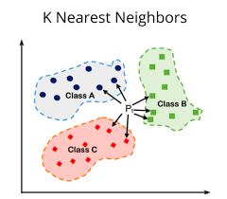k-NN is a type of classification where the function is only approximated locally and all computation is deferred until function evaluation. Since this algorithm relies on distance for classification, if the features represent different physical units or come in vastly different scales then normalizing the training data can improve its accuracy dramatically.

Figure(3)

The neighbors are taken from a set of objects for which the class (for k-NN classification) or the object property value (for k-NN regression) is known. This can be thought of as the training set for the algorithm, though no explicit training step is required.

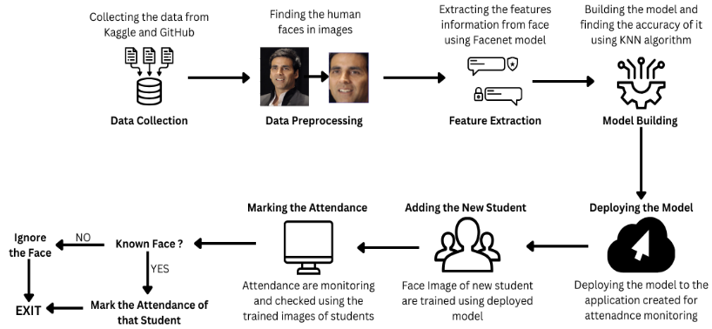

Figure(4) : Proposed System

1. Data Collection:

The system begins by gathering data from two sources: Kaggle and GitHub. This data likely consists of images containing faces.

1. Data Preprocessing:

Once collected, the data goes through a preprocessing stage. This stage may involve cleaning the data, removing irrelevant information, and formatting it for use in the system.

1. Feature Extraction:

After preprocessing, the system extracts features from the facial images. Facial recognition systems typically work by identifying specific features in faces, such as the distance between the eyes or the shape of the jawline. In the proposed system, a model called Facenet is used for feature extraction.

1. Model Building:

Once features are extracted, a model is built using a KNN algorithm to identify faces in images. The system likely trains the model on a dataset of labeled images, where each image has been identified as containing a face or not containing a face.

1. Marking Attendance:

The system is now ready to mark attendance. When a new image is presented to the system, it first goes through a process to determine if a human face is present in the image.

1. Known Face?

If a face is detected, the system then tries to determine if the face is a known student. It accomplishes this by comparing the extracted features from the new image to the features of faces in the trained model.

If there is a match, the system recognizes the student and marks their attendance.

If there is no match, the system concludes the face is an unknown student.

1. New Student

In the case of an unknown student, the system prompts the user to add the new student's information. The system likely captures an image of the student's face at this point.

Once the new student's information is added, the system uses the deployed model to train the student's facial data into the system.

1. Deployment

Finally, the system is deployed, likely meaning it is integrated into an application designed to monitor attendance.

Overall, this proposed system diagram outlines a facial recognition system designed to automate the process of marking student attendance.

# **IV. Results**

This section presents the outcomes of the proposed model, focusing on metrics such as training, validation, and test accuracies, as well as visualizations to interpret the performance and embedding distributions.

A. Average Accuracy Across Iterations

The performance of the proposed model is analyzed by computing average accuracies over every 100 iterations for training, validation, and test datasets. This approach helps observe the stability and consistency of the model over time.

Table shows the average accuracies for every 100 iterations for the training, validation, and test datasets.

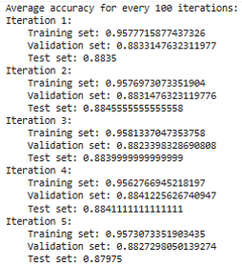

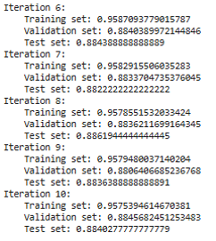

A line plot visualizing the average accuracy trends across iterations is shown in Figure (5).

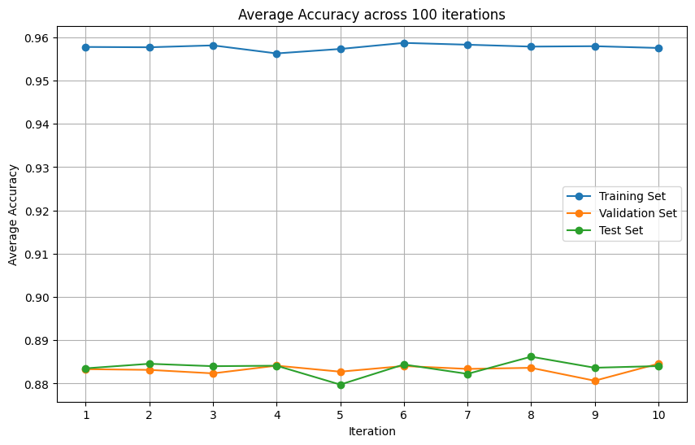

Figure (5): Line plot of average accuracy trends

B: Face Embedding Distribution Visualization

To explore the distribution of face embeddings generated by the model, **t-SNE (t-Distributed Stochastic Neighbor Embedding)** was employed for dimensionality reduction, mapping high-dimensional embeddings to a 2D space.

The t-SNE scatter plot (Figure 6) shows distinct clusters, highlighting the model's ability to differentiate between classes.

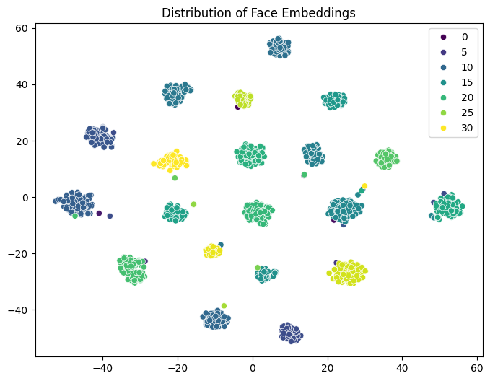

Figure 6: Scatter plot of face embeddings using t-SNE

C: 3D Representation of Accuracy Relations

To analyze the relationship between training, validation, and test accuracies for the first iteration, a 3D scatter plot was generated. This visualization allows for a comprehensive view of the model's performance metrics cohesively.

Figure(7) presents a 3D scatter plot that visually compares the accuracies of the first iteration. This representation offers insights into the model's inter-metric relationships.

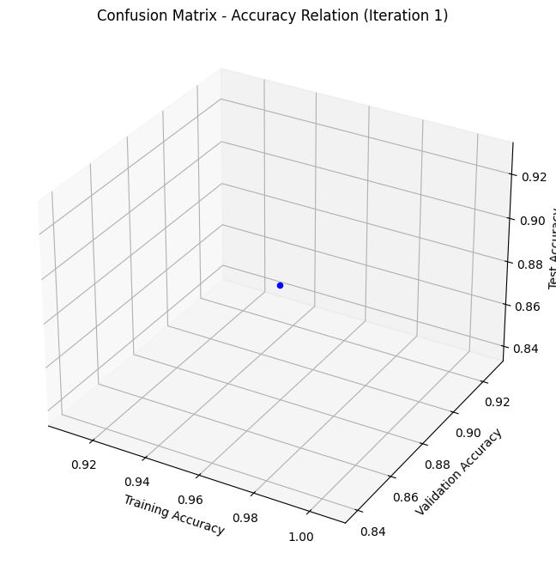

Figure(7): 3D scatter plot of accuracy relations

D: IMPLICATIONS OF THE APPLICATION

This section discusses the practical implications of implementing the proposed system using Firebase Database and Firebase Storage for data storage and management. These tools enable efficient record keeping and storage of associated images, ensuring scalability and security for real-world applications.

Firebase Database:

Firebase Database is used to store records such as user information, attendance logs, and metadata for the application. Its real-time synchronization capabilities ensure that data updates are reflected instantaneously across all connected devices.

**Key Features:**

* Real-time data synchronization.
* Secure and scalable architecture.
* Simplified integration with front-end frameworks.

Include a relevant image of the Firebase Database structure or workflow diagram here.

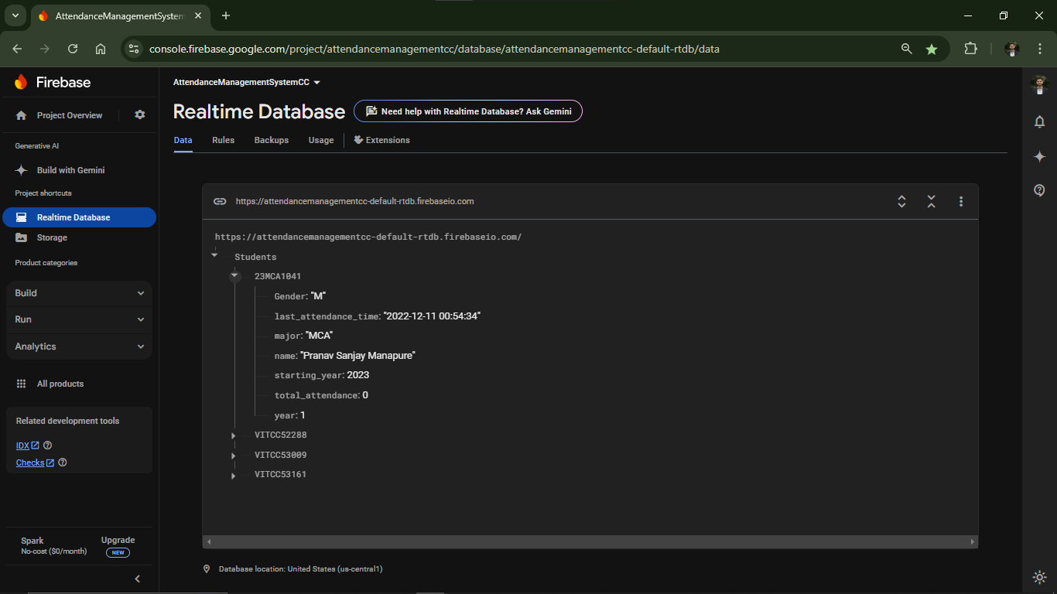

Figure (8): Firebase Database Workflow

Firebase Storage:

Firebase Storage is used to store image data, including facial photographs and processed embeddings, enabling seamless retrieval and use during recognition tasks. It ensures data security through advanced encryption and is designed to handle large-scale storage needs.

**Key Features:**

* High scalability for storing image and binary data.
* Robust security protocols, including authentication and access control.
* Easy integration with Firebase Database for combined functionality.

Include a relevant image of the Firebase Storage structure or workflow diagram here.



Figure 7.2 here: Firebase Storage Workflow

Real-Time Attendance Tracking:

The system utilizes facial recognition algorithms to capture, identify, and log attendance instantly. It integrates seamlessly with Firebase Database and Storage to update records in real time. The application is designed with a user-friendly interface to ensure smooth operation.

**Key Features:**

* Real-time face detection and recognition.
* Instant attendance logging in the database.
* Live updates visible to the user.

Include the application screenshot here to provide a clear representation of the interface and its functionality.



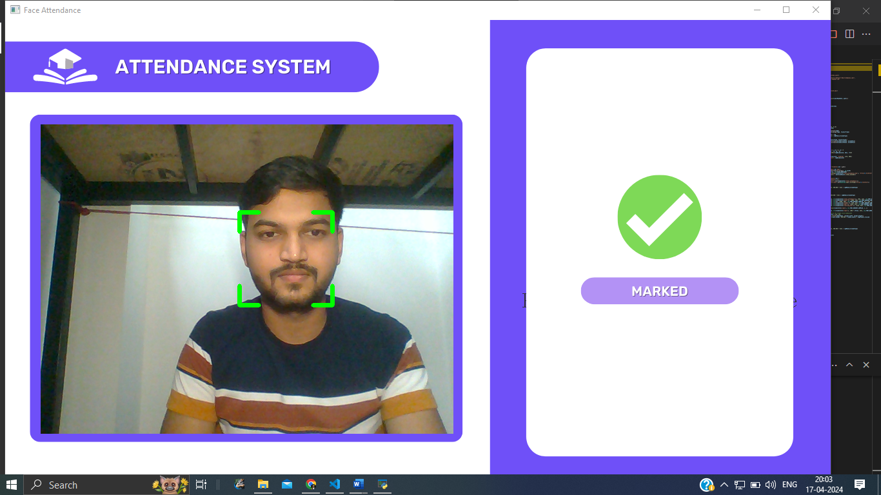

Figure (9): Screenshot of Real-Time Attendance Tracking

# **V. Discussion**

The project's primary goal was to achieve high accuracy in identifying individuals in challenging conditions. Additionally, we aimed to enable facial recognition on moving faces, particularly in real-time surveillance scenarios. Another important objective was to minimize the power consumption of face recognition systems to enhance their efficiency and suitability for various environments. By achieving an impressive accuracy rate of 97%, our project demonstrates significant progress in meeting these objectives. This success signifies advancements in facial recognition technology, paving the way for more reliable solutions in identity verification and surveillance applications.

# **VI. Conclusion**

After carefully studying various ways to make facial recognition technology work better, we found that there were some important gaps in how these methods were being used. To fill these gaps and improve facial recognition systems, we came up with a new approach. This approach brings together different techniques like FaceNet for building the main part of the system, KNN for checking how well it works, Haar Cascade for spotting faces, and Flask for making it easy to use. Our project using these methods achieved an accuracy rate of 97.76%, which is good. It shows that we're making progress in creating facial recognition systems that can be very useful in many situations.

##### **VII. Future Scope**

The future scope for this project is vast and promising. With its high accuracy rate and robust performance, the system can be scaled up for large-scale implementation, addressing the challenge of adding one student at a time. By leveraging CCTV infrastructure, facial recognition technology can be seamlessly integrated into existing surveillance systems, enhancing security measures and streamlining attendance monitoring processes in various settings such as schools, universities, and workplaces. Additionally, the project lays the groundwork for further advancements in facial recognition technology, opening up possibilities for broader applications beyond attendance monitoring, including access control, personalized services, and targeted advertising. Overall, the project's success paves the way for widespread adoption and continued innovation in the field of facial recognition based solutions.

**REFERENCES**

1. Andre Budimana, Fabian, Ricky Aryatama Yaputera, Said Achmad, Aditya Kurniawan, “Student attendance with face recognition (LBPH or CNN): Systematic literature review”, International Conference on Computer Science and Computational Intelligence, 2022
2. Ahmad Anshari, Sulistyo Aris Hirtranusi, Dana Indra Sensuse, Kautsarina, Ryan Randy Suryono, “Face Recognition for Identification and Verification in Attendance System: A Systematic Review”, IEEE International Conference on Communication, Networks and Satellite (Comnetsat), 2021
3. Ms. Sarika Ashok Sovitkar, Dr. Seema S. Kawathekar, “Comparative Study of Feature-based Algorithms and Classifiers in Face Recognition for Automated Attendance System”, International Conference on Innovative Mechanisms for Industry Applications, 2020
4. HUDA.H.Mady, Shadi M.S. Hilles, “Efficient Real Time Attendance System Based on Face Detection Case Study “MEDIU Staff””, International Journal of Contemporary Computer Research, 2017
5. Smitha, Pavithra S Hegde, Afshin, “Face Recognition based Attendance Management System”, International Journal of Engineering Research & Technology, 2020
6. Dhanush Gowda H.L, K Vishal, Keertiraj B. R, Neha Kumari Dubey, Pooja M. R., “Face Recognition based Attendance System”, International Journal of Engineering Research & Technology, 2020
7. Khawla Alhanaeea, Mitha Alhammadia, Nahla Almenhalia, Maad Shatnawia, “Face Recognition Smart Attendance System using Deep Transfer Learning”, International Conference on Knowledge-Based and Intelligent Information & Engineering Systems, 2021
8. Foteini P. Filippidou and George A. Papakostas, “Single Sample Face Recognition Using Convolutional Neural Networks for Automated Attendance Systems”, IEEE Xplore, 2020
9. Dr A Manjula, D. Kalpana, Sanjay Guguloth, “Facial Recognition Attendance Monitoring System using Deep Learning Techniques”, International Journal For Innovative Engineering and Management Research, 2023
10. Anju V Das, Anjana Shyju, and Thomas Varghese and Nisha Mohan P M, “Face Recognition Based Attendance Management System Using Machine Learning”, International Journal Of Innovative Research In Technology, 2019
11. Aparna Trivedi, Chandan Mani Tripathi, Dr. Yusuf Perwej, Ashish Kumar Srivastava, Neha Kulshrestha, “Face Recognition Based Automated Attendance Management System”, International Journal of Scientific Research in Science and Technology, 2022
12. Praveen K. Sah, Mamata Garanayak, Sujata Chakravarty, Bijay K. Paikaray, Rakesh Sharma and Suneeta Satpathy, “Student Attendance System Based on Face Recognition and Machine Learning”, Advances in Computation Intelligence, 2022
13. Soumitra Chowdhury, Sudipta Nath, Ashim Dey and Annesha Das, “Development of an Automatic Class Attendance System using CNN-based Face Recognition”, Emerging Technology in Computing, Communication and Electronics, 2020
14. Nandhini R, Duraimurugan N, S. P. Chokkalingam, “Face Recognition Based Attendance System”, International Journal of Engineering and Advanced Technology, 2019
15. Anuj Singh, Nikhil Rawat, Rajan Kesri, “Face Recognition Based Attendance System”, International Journal for Multidisciplinary Research,